Аудирование А8-А14
Warming Up.

1
How long will the man stay at the hotel in total?

2
What does the man want to buy?
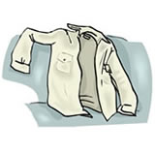

3
What time will the train arrive?
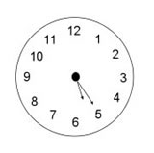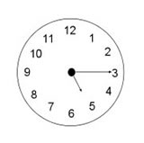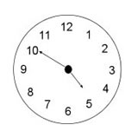

4
What will they buy?

5
Where is the post office?
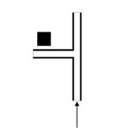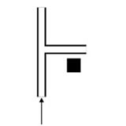

Задание 1.

Задание 2.
Упражнение 3.
Вы услышите рассказ молодого человека о его опыте обучения в школе пилотов.
В заданиях А8-А14 обведите цифру 1, 2 или 3, соответствующую выбранному вами варианту ответа. Вы услышите запись дважды.
А8. The narrator decided to get a pilot's license because
- his school teacher encouraged him to do so.
- his father had a single engine aircraft.
- he was interested in aviation science.
A9. The narrator signed up for the aviation school right after his discovery flight because he had been
- fascinated by the beauty of the sky.
- allowed to fly the plane.
- offered a short-term course.
A10. The narrator was planning to get his license
- before his final school exams.
- right after his final school exams.
- before leaving for college.
A11. The new instructor found the narrator's knowledge of the theory
1) very good 2) adequate 3) unsatisfactory.
A12. The narrator's test results were
- good enough for him.
- lower the pass mark.
- far beyond his expectations.
A13. The narrator's family wanted him to
- quit the course.
- continue the course.
- take a break from the course.
A14. Since the time the author got his license he has
- had no chance to fly.
- flown quite regularly.
- hardly ever flown.

Использованная литература:
1.Ю.С. Веселова, 7 класс. Сборник тренировочных и проверочных заданий (в формате ЕГЭ) «Интеллект-Центр, М, 2010
2. Федеральный банк экзаменационных материалов , М, 2008
3. http://www.examenglish.com/KET/ket_listening_part1.htm

