Тема: Schools in Britain
(5 класс)
Цель: развитие умения понимать аутентичный фильм.
Задачи: развитие умений аудирования, диалогической речи и чтения по теме; развитие интеллектуальных способностей учащихся; развитие культуры восприятия фактов культуры, явлений страны изучаемого языка.
Речевой материал: раздаточный материал для групповой работы.*
Оснащение: видеофильм “Schools”. **

Ход урока
I. Организационный момент.
1. Приветствие.
Teacher. Good afternoon, children! Glad to see you!
2. Ознакомление учащихся с задачами и планом предстоящего урока.
Teacher. At our previous lessons we read some information about schools in Britain. Today we are going to watch a short film about British schools and try to find out some new facts or sum up the known ones. You will work in groups, so you can share your opinions and discuss the tasks.
II. Lead-in (см. Приложение 1).
Teacher. Before we watch the film let’s do two quizzes.
1. Quiz Window.
Teacher. Discuss the facts and tick the correct information. You have 1–2 minutes … So, what information is correct? (Один человек от группы зачитывает информацию.)
Suggested answers:
Pupil 1. At most schools students wear a uniform.
Pupil 2. There are about 22 students in a secondary school class.
OK, we shall go back and check the quiz a little later if we need.
2. Word Window.
Teacher. You should put the words into three columns. One word is odd. You have about 2 minutes … Now read:
a) subjects b) types of schools c) sports
(Один человек от группы зачитывает информацию.)
Suggested answers:
Pupil 1. Geography, literature, history …
Pupil 2. Primary, independent, state …
Which word is odd?
Pupil 1. The odd word is “uniform”.
III. Работа с фильмом.
1. Первый просмотр фильма.
Teacher. Now we shall watch the film and you’ll try to do the tasks. You should be attentive. (Учащиеся получают лист с тремя заданиями (см. Приложение 2), смотрят фильм, затем выполняют задания.)
a) Number the subjects.
b) Tick the activities you see.
c) Cross out the incorrect answer.
(один человек от группы зачитывает информацию).
Suggested answers:
a) Pupil 1. Maths, Art, Food Technology, …
b) Pupil 2. Netball, cooking, badminton, …
c) Pupil 3. The incorrect answers are: half an hour, most, five, chess.
2. Второй просмотр фильма (см. Приложение 3).
Teacher. Let’s watch the film again and try:
a) to complete the table with words and numbers … Let’s check the task (один человек от группы зачитывает информацию).
Suggested answers:
Pupil 1. Children from 5 to 11 go to primary school.
Pupil 2. Children from 11 to 16 go to secondary school.
b) put the information in each column … Let’s check it (один человек от группы зачитывает информацию).
Suggested answers:
Pupil 1. 92 % of British schools are state.
Pupil 2. The government pays for these.
c) let’s go back to the Quiz Window and check it … (если при выполнении задания были допущены ошибки или информация была отмечена неполно).
IV. Competition (см. Приложение 4).
Teacher. We’ve watched the film and now you’ll compete. Imagine that you are British students. You should make sentences about education and school that everyone in the group agrees with. Examples can help you. (Учащиеся составляют предложения. Победителем становится та группа, которая составит как можно больше предложений.)
Suggested answers:
Pupil 1. We don’t like a lot of homework.
Pupil 2. School food is all right.
V. Role – play (см. Приложение 5).
Teacher. Work in pairs. Prepare for the interview. One of you is a British student, the other is a film presenter. You have 1-2 minutes to get ready. (От каждой группы в диалоге участвует одна пара.)
Suggested answers:
Pupil 1. Do you enjoy school?
Pupil 2. Yes, I do.
Pupil 1. What’s your favourite subject?
Pupil 2. Maths, I think.
Pupil 1. What do you think of homework?
Pupil 2. As for me, I don’t mind it…
VI. Чтение письма (см. Приложение 6).
Teacher. You will read the girl’s letter and
a) put some lines in the correct place in the letter. (Учащиеся читают текст про себя и вставляют пропущенные фразы. Проверяем.)
Suggested answers:
Pupil 1. The first is “e”: Thank you for your letter …
b) mark true and false sentences (учащиеся выполняют задание. Проверяем).
Suggested answers:
Pupil 1. Anna loves music.
Pupil 2. Maria’s family is quite large.
VIII. Итоги урока.
Домашнее задание (см. Приложение 7).
Teacher. You have read Ann’s letter and at home you’ll have to write the answer. You should tell her about your school and your life at school.

Приложения

Приложение 1
1. Do you know anything about schools in Britain? Try this quiz.

Quiz Window
Tick () the correct information.
a) Most children start primary school at the age of 7.
b) About 20 % of 18-yearolds go to university.
c) At most schools students wear a uniform.
d) There are about 22 students in a secondary school class.
e) Students begin learning a foreign language at 15.
f) All students have music lessons.
g) Most parents in Britain pay for their children’s education.

2. Now try this.

Word Window
Put the words below into the correct columns. One word doesn’t go. Which one?
primary football science
rugby independent state
religion uniform secondary
geography history badminton
literature netball boarding
Subjects | Types of school | Sports

Key:
Quiz Window: b, c, d.
Word Window: The odd word is “uniform”.

Приложение 2
1. Number the subjects in the order you see them in the film.
1) French.
2) Design and Technology.
3) Food Technology.
4) Maths.
5) Information Technology.
6) Art.
7) Science.

Key: 4, 6, 3, 2, 7, 1, 5.

2. Watch the film and tick () the activities you see.

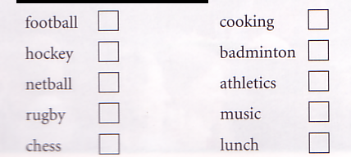

Key: football, netball, cooking, badminton, music, lunch.

3. Cross out the incorrect answer in the sentences below.

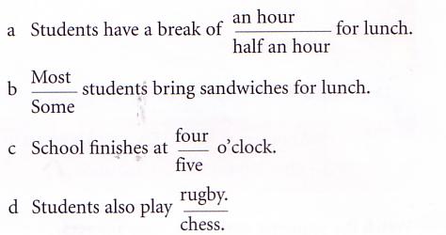

Key: a) half an hour b) most c) five d) chess

Приложение 3
1. Try to complete the table with words and numbers from the box.
training | university | 17 5
70 | secondary | advanced
primary | certificate | 20 16

Age | Education
…–11 | 100 % of students go to ……………. school.
11–… | 100 % of students go to ……………. school.
 | At 16, in England, they take GCSE examinations (General ……………. Of Secondary Education).
…–18 | … % of students continue at school. At 18 they take “A” levels (……………. Level examinations).
18 + | 20 % of 18-year-olds go to …………….
 | Another … % of 18-year-olds go on to other kinds of education and …………….

Key: 5 – primary; 16 – secondary; certificate; 17–20 advanced; university; 70; training.

2. Try to put the correct information in each column on the right.

C
Some of these are boarding schools
A
92 %
of British schools
B
8 %
of British schools

D
The
government pays for these
F
Eton
is one of these
E
The
parents pay for these

State schools | Independent schools

Key: state schools - A, D; independent schools – B, C, E, F.

Приложение 4

Competition
1. Work in groups of four. Talk about school and education. Make sentences that everyone in the group agrees with.
For example:
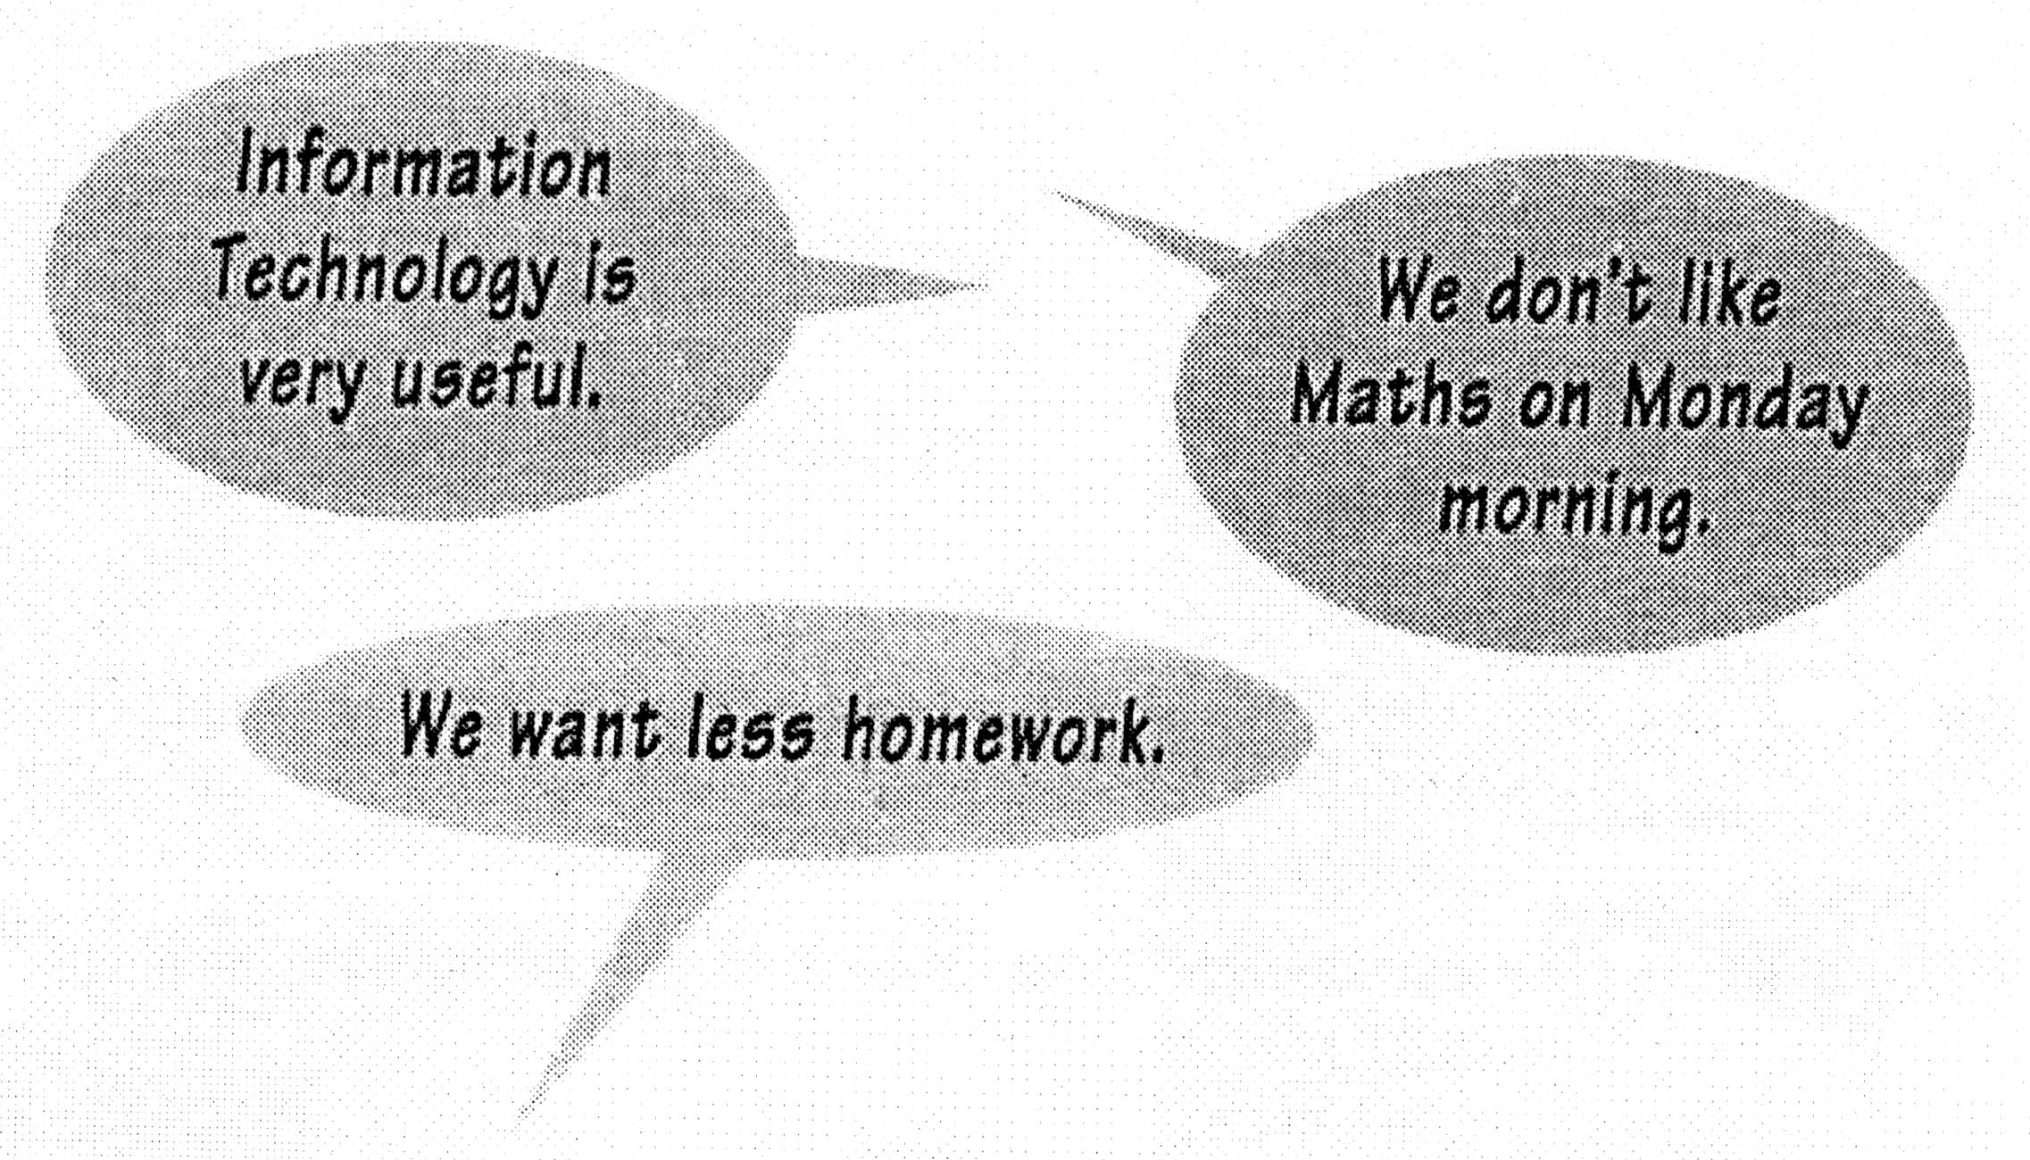

2. Write down as many sentences as possible. The group with the most sentences is the winner.

Приложение 5

Role-play
1. Work in pairs (As and Bs). Prepare for the interview.
Pair A: You are “Window on Britain” presenters. You are going to interview a student about his/her school life. You want to find out how much he/she enjoys school Prepare your questions. (Look at the box for help.)
Do you enjoy … ?
Do you like … ?
What’s your favourite … ?
What do you like about ... ?
What do you think about ... ?

Pair B: A “Window On Britain” presenter is going to inter view you about your school life. Prepare your answers. (Look at the box for help.)
subjects class size
lunch/school food ages
homework exams
uniform music
start and finish times sports
morning and afternoon classes

2. Now make new pairs (one A and one B) and act out the interview.
Приложение 6
1. Read this letter and put the lines in the correct place in the letter.
a) You want to know about my school,
b) After school I play netball,
c) My brother, Tom,
d) I’m in Year Eight now,
e) Thank you for your letter.
Abingdon
OX14 2BU
England
18th May
Dear Maria,
(1) ………………………………………………………………….
Your family is very interesting. You’ve got so many brothers and sisters! And your uncle is English – where’s he from?

(2) ………………………………………………………………….
Well, i go to the John Mason School in Abingdon. It’s quite a big school – over 900 students – but it’s very friendly. I’m in a class with about 30 other students.

(3) …………………………………………………………………..
I do all the usual subjects: English, Maths, Science, History. Geography and so on. And this year we do two foreign languages – French and German. Sorry – not Italian! I also do Music. It’s my favourite subject. I play the piano and the guitar. Do you play a musical instrument?
(4) ………………………………………………………………….
and I also belong to the Drama club. We meet every Tuesday afternoon, and at the end of the year we perform a play for the school and all the parents.
(5) ………………………………………………………………….
is at the school too but he’s in Year Eleven. Poor Tom! He’s got his GCSE exams in June so he has lots of homework! He plays rugby in the winter and cricket in the summer.

Please write and tell me all about your school

Best wishes,
Anna

2. Mark the following sentences T (true) or F (false).
a) Maria is Italian.
b) Maria’s family is quite large.
c) Maria goes to school in Abingdon.
d) Anna learns Italian.
e) Anna loves music.
f) Netball is on Tuesday afternoons.
g) Anna has got her GCSE exams in June.
h) Tom plays netball.

Key: 1. 1e, 2a, 3d, 4b, 5c.
2. True: a, b, e.
Приложение 7
Write a letter to Anna telling her about your school and your life at school.
Tell her about:
- your class;
- what you like and dislike about your school;
- the subjects you study;
- sports and activities;
- any brothers and sisters at school.
Dear Anna,
Best wishes,

Список литературы
- Верещагина, И. Н., Афанасьева, О. В. Английский язык: учебник для 5 класса школ с углубленным изучением английского языка. – 2-е изд. – М.: Просвещение, 1997, 2007.
- Кошманова, И. И. 90 устных тем на английском языке. – М.: Айрис-пресс, 2004.
- Тарнаева, Л. П. Тесты по грамматике английского языка. – Спб.: Союз, 2000.
- Current. N 4. – London.: Scholastic. Inc. Mary Glasgow Magazines, 2003.
- Spotlight. Английский в фокусе: учебник для общеобразовательных учреждений / [Ю. Е. Ваулина, Дж. Дули, О. Е. Подоляко, В. Эванс]. – М.: Express Publishing: Просвещение, 2005.
- Oxford English Video “Windows on Britain”. Oxford University Press.
- Richard MacAndrew ,“Windows on Britain”, Activity Book. Oxford University Press.

* Упражнения взяты из “Window on Britain. Activity Book”. Richard MacAndrew.
** Oxford English Video “Window on Britain” 1 and 2. // © Oxford University Press.

