Super pop (lyrics) / TO THE TEACHER
If I was an animal, I'd be a lion
If I was a car, I'd be an Aston Martin
If I was a genius, I'd be Isaac Newton
If I was a hero, I'd be Martin Luther
If you want to reach the top (reach the top)
If you do, you'll never stop (never stop)
(The top)
If I was an actor, I'd be Marlon Brando (the top)
If I was a painter, I'd be Frida Kahlo (the top)
If I was a drink, I'd be a lemon drop (the top)
If I was a song, I would be super pop
If you want to reach the top (reach the top)
If you do, you'll never stop (never stop)
If you want to reach the top (reach the top)
If you do, you'll never stop (never stop)
(The top)
If I was a star, I would be who I am today
If I was a fighter, I'd be Casius Clay
If I was emotion, I would be intense
If I was a man, I would be president
I'll be different
If I'm the president
I'll be different
If I'm the president
If I was an animal, I'd be a dog
If I was a dog, I would be a man
If I was a man, I'd be the president
If I was the president, I'd be different
If you want, you can reach the top (reach the top)
If you do, you'll never stop (never stop)
If you want, you can reach the top (reach the top)
If you do, you'll never stop (never stop)
(The top)
If you want to reach the top
You would start and never stop (never stop - the top)
If you want to reach the top
You would start and never stop (never stop)
If you want to reach the top (never stop)
You would start and never stop (never stop - the top)

- Look at the images and guess who these people are and what they are famous for!
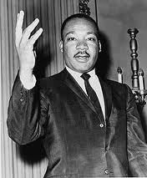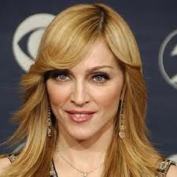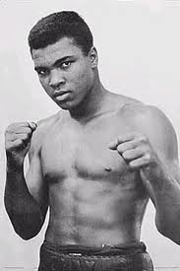
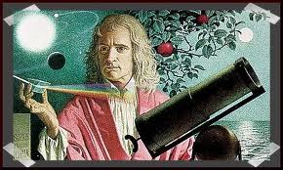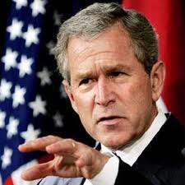
- Listen to the song and fill in the blanks and sing together with Madonna!

If I was an animal, I'd be a _________
If I was a _________, I'd be an Aston Martin
If I was a genius, I'd be _________
If I was a hero, I'd be _________
If you want to reach the top (reach the top)
If you do, you'll _________
If I was an _________, I'd be Marlon Brando (the top)
If I was a _________, I'd be Frida Kahlo (the top)
If I was a drink, I'd be a _________ (the top)
If I was a _________, I would be super pop
If you want to reach the top (reach the top)
If you do, you'll never stop (never stop)
If I was a _________, I would be who I am today
If I was a fighter, I'd be _________
If I was _________, I would be intense
If I was a man, I would be _________
I'll be _________
If I'm the _________
If I was an animal, I'd be a _________
If I was a dog, I would be a _________
If I was a man, I'd be the _________
If I was the president, I'd be _________
Fill in the blanks with your own ideas about your personality. For example, if you were an animal, what animal would it be? – lion, cat, horse.. Why do you identify yourself with these objects and people? Tell the class more about your ambitions and personality.
If I was an animal, I'd be a _________
If I was a car, I'd be _________
If I was a genius, I'd be _________
If I was a hero, I'd be _________
If I was an actor, I'd be _________
If I was a painter, I'd be _________
If I was a drink, I'd be a _________
If I was a a song , I would _________
If I was a star, I would _________
If I was a fighter, I'd be _________
If I was emotion, I would _________
If I was a man, I would be _________
GOOD LUCK! HAVE FUN!!!

